- Program ID : VA008MA1

- Display Layout
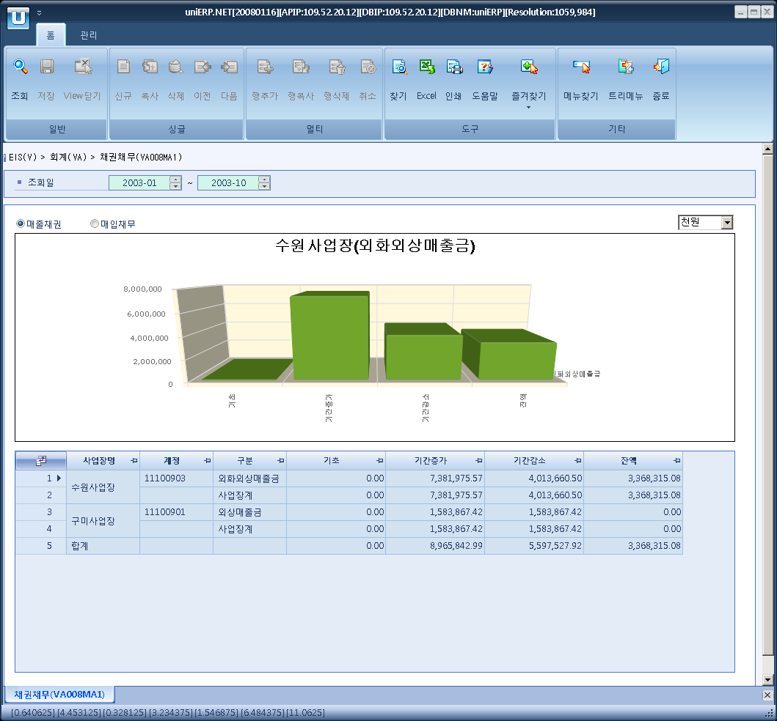

- Event flow
- Click Query button
- OnFncQuery -> DbQuery -> DataChange
- Display Unit combo change
- uniCombo1_ValueChanged -> DataChange

- SQL Statements
- Profit and Loss
SELECT a.ar_ap_flag, MAX(b.minor_nm) AS ar_ap_name,
ISNULL(a.biz_area_cd, 'ZZZZZ') AS biz_area_cd,
CASE WHEN a.biz_area_cd IS NULL THEN '합계' ELSE MAX(c.biz_area_nm) END AS biz_area_nm,
ISNULL(a.acct_cd, 'ZZZZZ') AS acct_cd,
CASE WHEN a.biz_area_cd IS NULL THEN NULL
ELSE CASE WHEN a.acct_cd IS NULL THEN '사업장계' ELSE MAX(d.acct_nm) END
END AS acct_nm,
ISNULL(SUM(bas_amt), 0) AS bas_amt, ISNULL(SUM(mdl_inc_amt), 0) AS inc_amt,
ISNULL(SUM(mdl_dec_amt), 0) AS dec_amt, ISNULL(SUM(end_amt), 0) AS end_amt
FROM (SELECT b.biz_area_cd, a.acct_cd,
CASE WHEN SUBSTRING(a.acct_type, 1, 1) = 'I' THEN 'AR' ELSE 'AP' END AS ar_ap_flag,
CASE WHEN b.fisc_yr + b.fisc_mnth + b.fisc_dt <= @strFrYyyyMm + '00' THEN
CASE WHEN SUBSTRING(a.acct_type, 1, 1) = 'I' THEN b.dr_loc_amt - b.cr_loc_amt
ELSE b.cr_loc_amt - b.dr_loc_amt
END
END AS bas_amt,
CASE WHEN b.fisc_yr + b.fisc_mnth + b.fisc_dt > @strFrYyyyMm + '00' AND b.fisc_dt > '00' THEN
CASE WHEN SUBSTRING(a.acct_type, 1, 1) = 'I' THEN b.dr_loc_amt ELSE b.cr_loc_amt END
END AS mdl_inc_amt,
CASE WHEN b.fisc_yr + b.fisc_mnth + b.fisc_dt > @strFrYyyyMm + '00' AND b.fisc_dt > '00' THEN
CASE WHEN SUBSTRING(a.acct_type, 1, 1) = 'I' THEN b.cr_loc_amt ELSE b.dr_loc_amt END
END AS mdl_dec_amt,
CASE WHEN b.fisc_yr + b.fisc_mnth > @strFrYyyyMm AND b.fisc_dt > '00' THEN
CASE WHEN SUBSTRING(a.acct_type, 1, 1) = 'I' THEN b.dr_loc_amt - b.cr_loc_amt
ELSE b.cr_loc_amt - b.dr_loc_amt
END
ELSE CASE WHEN SUBSTRING(a.acct_type, 1, 1) = 'I' THEN b.dr_loc_amt - b.cr_loc_amt
ELSE b.cr_loc_amt - b.dr_loc_amt
END
END AS end_amt
FROM a_acct a
INNER JOIN a_gl_sum b
ON b.acct_cd = a.acct_cd
AND b.fisc_yr = CASE WHEN @strClYyyyMM >= @strFrYyyyMm THEN SUBSTRING(@strFrYyyyMm, 1, 4)
ELSE SUBSTRING(@strClYyyyMM, 1, 4)
END
AND b.fisc_mnth BETWEEN CASE WHEN @strClYyyyMM >= @strFrYyyyMm THEN SUBSTRING(@strFrYyyyMm, 5, 2)
ELSE SUBSTRING(@strClYyyyMM, 5, 2)
END
AND CASE WHEN @strClYyyyMM >= @strFrYyyyMm THEN
CASE WHEN SUBSTRING(@strFrYyyyMm, 1, 4) = SUBSTRING(@strToYyyyMm, 1, 4) THEN
SUBSTRING(@strToYyyyMm, 5, 2)
ELSE '12'
END
ELSE CASE WHEN SUBSTRING(@strClYyyyMM, 1, 4) = SUBSTRING(@strToYyyyMm, 1, 4) THEN
SUBSTRING(@strToYyyyMm, 5, 2)
ELSE '12'
END
END
WHERE a.acct_type IN ('I0', 'I1', 'JA', 'JD')
UNION ALL
SELECT b.biz_area_cd, a.acct_cd,
CASE WHEN SUBSTRING(a.acct_type, 1, 1) = 'I' THEN 'AR' ELSE 'AP' END AS ar_ap_flag,
CASE WHEN b.fisc_yr + b.fisc_mnth + b.fisc_dt <= @strFrYyyyMm + '00' THEN
CASE WHEN SUBSTRING(a.acct_type, 1, 1) = 'I' THEN b.dr_loc_amt - b.cr_loc_amt
ELSE b.cr_loc_amt - b.dr_loc_amt
END
END AS bas_amt,
CASE WHEN b.fisc_yr + b.fisc_mnth + b.fisc_dt > @strFrYyyyMm + '00' AND b.fisc_dt > '00' THEN
CASE WHEN SUBSTRING(a.acct_type, 1, 1) = 'I' THEN b.dr_loc_amt ELSE b.cr_loc_amt END
END AS mdl_inc_amt,
CASE WHEN b.fisc_yr + b.fisc_mnth + b.fisc_dt > @strFrYyyyMm + '00' AND b.fisc_dt > '00' THEN
CASE WHEN SUBSTRING(a.acct_type, 1, 1) = 'I' THEN b.cr_loc_amt ELSE b.dr_loc_amt END
END AS mdl_dec_amt,
CASE WHEN b.fisc_yr + b.fisc_mnth > @strFrYyyyMm AND b.fisc_dt > '00' THEN
CASE WHEN SUBSTRING(a.acct_type, 1, 1) = 'I' THEN b.dr_loc_amt - b.cr_loc_amt
ELSE b.cr_loc_amt - b.dr_loc_amt
END
ELSE CASE WHEN SUBSTRING(a.acct_type, 1, 1) = 'I' THEN b.dr_loc_amt - b.cr_loc_amt
ELSE b.cr_loc_amt - b.dr_loc_amt
END
END AS end_amt
FROM a_acct a
INNER JOIN a_gl_sum b
ON b.acct_cd = a.acct_cd
AND b.fisc_yr BETWEEN CASE WHEN @strClYyyyMM >= @strFrYyyyMm THEN SUBSTRING(@strFrYyyyMm, 1, 4) + 1
ELSE SUBSTRING(@strClYyyyMM, 1, 4) + 1
END
AND SUBSTRING(@strToYyyyMm, 1, 4) - 1
WHERE CONVERT(NUMERIC, SUBSTRING(@strToYyyyMm, 1, 4)) -
CASE WHEN @strClYyyyMM >= @strFrYyyyMm THEN SUBSTRING(@strFrYyyyMm, 1, 4)
ELSE SUBSTRING(@strClYyyyMM, 1, 4)
END > 1
AND a.acct_type IN ('I0', 'I1', 'JA', 'JD')
UNION ALL
SELECT b.biz_area_cd, a.acct_cd,
CASE WHEN SUBSTRING(a.acct_type, 1, 1) = 'I' THEN 'AR' ELSE 'AP' END AS ar_ap_flag,
CASE WHEN b.fisc_yr + b.fisc_mnth + b.fisc_dt <= @strFrYyyyMm + '00' THEN
CASE WHEN SUBSTRING(a.acct_type, 1, 1) = 'I' THEN b.dr_loc_amt - b.cr_loc_amt
ELSE b.cr_loc_amt - b.dr_loc_amt
END
END AS bas_amt,
CASE WHEN b.fisc_yr + b.fisc_mnth + b.fisc_dt > @strFrYyyyMm + '00' AND b.fisc_dt > '00' THEN
CASE WHEN SUBSTRING(a.acct_type, 1, 1) = 'I' THEN b.dr_loc_amt ELSE b.cr_loc_amt END
END AS mdl_inc_amt,
CASE WHEN b.fisc_yr + b.fisc_mnth + b.fisc_dt > @strFrYyyyMm + '00' AND b.fisc_dt > '00' THEN
CASE WHEN SUBSTRING(a.acct_type, 1, 1) = 'I' THEN b.cr_loc_amt ELSE b.dr_loc_amt END
END AS mdl_dec_amt,
CASE WHEN b.fisc_yr + b.fisc_mnth > @strFrYyyyMm AND b.fisc_dt > '00' THEN
CASE WHEN SUBSTRING(a.acct_type, 1, 1) = 'I' THEN b.dr_loc_amt - b.cr_loc_amt
ELSE b.cr_loc_amt - b.dr_loc_amt
END
ELSE CASE WHEN SUBSTRING(a.acct_type, 1, 1) = 'I' THEN b.dr_loc_amt - b.cr_loc_amt
ELSE b.cr_loc_amt - b.dr_loc_amt
END
END AS end_amt
FROM a_acct a
INNER JOIN a_gl_sum b
ON b.acct_cd = a.acct_cd
AND b.fisc_yr = SUBSTRING(@strToYyyyMm, 1, 4)
AND b.fisc_mnth BETWEEN CASE WHEN @strClYyyyMM >= @strFrYyyyMm THEN
CASE WHEN SUBSTRING(@strFrYyyyMm, 1, 4) = SUBSTRING(@strToYyyyMm, 1, 4) THEN '13' ELSE '01' END
ELSE CASE WHEN SUBSTRING(@strClYyyyMM, 5, 2) = SUBSTRING(@strToYyyyMm, 1, 4) THEN '13' ELSE '01' END
END
AND SUBSTRING(@strToYyyyMm, 5, 2)
WHERE a.acct_type IN ('I0', 'I1', 'JA', 'JD')) a
LEFT JOIN b_minor b
ON b.minor_cd = a.ar_ap_flag
AND b.major_cd = 'A1046'
LEFT JOIN b_biz_area c
ON c.biz_area_cd = a.biz_area_cd
LEFT JOIN a_acct d
ON d.acct_cd = a.acct_cd
GROUP BY a.ar_ap_flag, a.biz_area_cd, a.acct_cd WITH ROLLUP
HAVING a.ar_ap_flag IS NOT NULL
ORDER BY a.ar_ap_flag, a.biz_area_cd, a.acct_cd

